**Project**

**Art gallery 2024**

**Cozireva Ana,**

**Student of USARB**

**Summary**

[**1. Short description 3**](https://docs.google.com/document/d/1LOtrBfsxF2gDGBMTnSIJDu9EcnubrpAwVyCHgJg5yRQ/edit#heading=h.ricxnres3di)

[**2.** **Web site structure 4**](https://docs.google.com/document/d/1LOtrBfsxF2gDGBMTnSIJDu9EcnubrpAwVyCHgJg5yRQ/edit#heading=h.pdy0bnvq859s)

[2.1. Navigation Bar 4](https://docs.google.com/document/d/1LOtrBfsxF2gDGBMTnSIJDu9EcnubrpAwVyCHgJg5yRQ/edit#heading=h.z1udgilxf0dl)

[2.2. Main page 4](https://docs.google.com/document/d/1LOtrBfsxF2gDGBMTnSIJDu9EcnubrpAwVyCHgJg5yRQ/edit#heading=h.hdmdyw8r1rpq)

[2.2.1. First screen - Into 4](https://docs.google.com/document/d/1LOtrBfsxF2gDGBMTnSIJDu9EcnubrpAwVyCHgJg5yRQ/edit#heading=h.rvvhl5mef1pa)

[2.2.2. Speakers 5](https://docs.google.com/document/d/1LOtrBfsxF2gDGBMTnSIJDu9EcnubrpAwVyCHgJg5yRQ/edit#heading=h.a8go5jajrl3q)

[2.2.3. Schedule 6](https://docs.google.com/document/d/1LOtrBfsxF2gDGBMTnSIJDu9EcnubrpAwVyCHgJg5yRQ/edit#heading=h.qdxri81v8zyu)

[2.3. Speakers 7](https://docs.google.com/document/d/1LOtrBfsxF2gDGBMTnSIJDu9EcnubrpAwVyCHgJg5yRQ/edit#heading=h.6898j3ppu6mz)

[2.4. Schedule 7](https://docs.google.com/document/d/1LOtrBfsxF2gDGBMTnSIJDu9EcnubrpAwVyCHgJg5yRQ/edit#heading=h.3csic8swx72d)

[2.5. Partners 7](https://docs.google.com/document/d/1LOtrBfsxF2gDGBMTnSIJDu9EcnubrpAwVyCHgJg5yRQ/edit#heading=h.3v9gue5nzlp4)

[2.6. News 7](https://docs.google.com/document/d/1LOtrBfsxF2gDGBMTnSIJDu9EcnubrpAwVyCHgJg5yRQ/edit#heading=h.1wrqe6ud5da)

[2.7. Contact 7](https://docs.google.com/document/d/1LOtrBfsxF2gDGBMTnSIJDu9EcnubrpAwVyCHgJg5yRQ/edit#heading=h.ni7b2l29s1z1)

[**3. Project duration and timelines 7**](https://docs.google.com/document/d/1LOtrBfsxF2gDGBMTnSIJDu9EcnubrpAwVyCHgJg5yRQ/edit#heading=h.b10xibtvakan)

**1.Short description**

Title: "Art gallery - Unlocking the World of Contemporary Art"

Welcome to Art gallery, a unique platform dedicated to contemporary art and culture. Our website is not just a gallery; it's a space where artists, collectors, and art lovers come together to create a community that inspires and opens new horizons.

Project Overview:

Art gallery is an interactive site that unites artists, curators, and audiences. Our goal is to promote contemporary art, support emerging talents, and create an accessible space for discussing relevant topics in the art world. Whether you're an artist, a collector, or simply interested in art Art gallery is the perfect place to find like-minded individuals and gain inspiration.

Artists: Get to know talented artists, their biographies, and their works. Discover their inspirations and creative processes.

Educational Materials: Access articles, videos, and resources dedicated to contemporary art, its history, and trends.

Virtual Gallery: Explore our online gallery featuring artists' works in a user-friendly format, allowing you to enjoy art from anywhere in the world.

Networking: Connect with other community members, exchange ideas, and participate in collaborative projects that promote the development of art.

Discussions and Debates: Engage in forums and discussions on pressing art-related issues, its role in society, and its cultural impact.

Curated Selections: Discover carefully selected collections of works that highlight the diversity and depth of contemporary art.

Social Projects: Learn about social initiatives and projects that use art to bring about change and address important issues.

Art News: Stay updated on the latest news, events, and trends in the art world.

Art gallery is not just a website; it’s an opportunity to expand your horizons, meet new talents, and become part of a dynamic community dedicated to contemporary art.

Join us at Art gallery and unlock a world full of inspiration, creativity, and understand ding.

**2.Tor**

1. **Project Overview:**  
   This ToR outlines the requirements and objectives for the website design project for Art gallery, an online platform dedicated to contemporary art. The project aims to create a user-friendly and visually appealing website to showcase the gallery's exhibitions, artists, and events.
2. **Objectives:**
   * Develop a modern, responsive, and mobile-friendly website.
   * Enhance user experience and navigation.
   * Showcase Art gallerie**’s** exhibitions, artists, and mission.
   * Increase online visibility and brand recognition within the art community.
3. **Scope of Work:**
   * Design and development of a custom website with **[X]** number of pages (e.g., Home, Exhibitions, Artists, News, Contact).
   * Integration of features such as a contact form, blog, event calendar, and social media links.
   * Creation of visually engaging graphics and multimedia elements to highlight artworks.
   * Content management system (CMS) integration for easy content updates.
   * SEO optimization for improved search engine rankings.
4. **Deliverables:**
   * Fully functional website with all specified features and pages.
   * High-resolution images and graphics used in the design.
   * Documentation for using the CMS (if applicable).
5. **Timeline:**  
   The project is expected to be completed by **[Insert Project Deadline]**. Regular progress updates and milestones will be established throughout the project.
6. **Budget:**  
   The budget for this project is **[Specify Budget Amount]**. Any additional costs beyond the agreed budget must be approved in advance.
7. **Team Responsibilities:**
   * Art gallery will provide content, branding guidelines, and any necessary information.
   * The design and development team will execute the website creation according to the specifications outlined in this ToR.
8. **Approval Process:**  
   **[Specify Approval Process, e.g., Weekly meetings for progress updates and feedback].**
9. **Contact Information:**
   * **[Project Manager's Name and Contact Information]**
   * **[Client's Contact Information]**
10. **Confidentiality:**  
    All project-related information and materials are considered confidential and should not be disclosed without proper authorization.
11. **Terms and Conditions:**  
    This ToR serves as a binding agreement between **ArtConnect** and the design and development team.
12. **Amendments:**  
    Any changes to this ToR must be agreed upon in writing by both parties.
13. **Acceptance:**  
    By signing below, both parties acknowledge their understanding and acceptance of the terms and conditions outlined in this ToR.

Client's Signature: ______________________________ Date: ________________

Project Manager's Signature: ______________________ Date: _______

## **Requirements**

### UI/UX - Colors

Main colors:

* Gray
* Black
* Yellow
* White

### Browsers, devices and resolutions

Browsers:

* IE6
* Opera
* Google chrome

Devices:

* PC
* Mobile devices

Resolutions:

* PC
  + From full HD to 8K
* Mobile devices
  + Width from 300 to 600

**3.Web site structure**

3.1 Navigation Bar



3.2 Main Page

3.2.1 First screen- Info

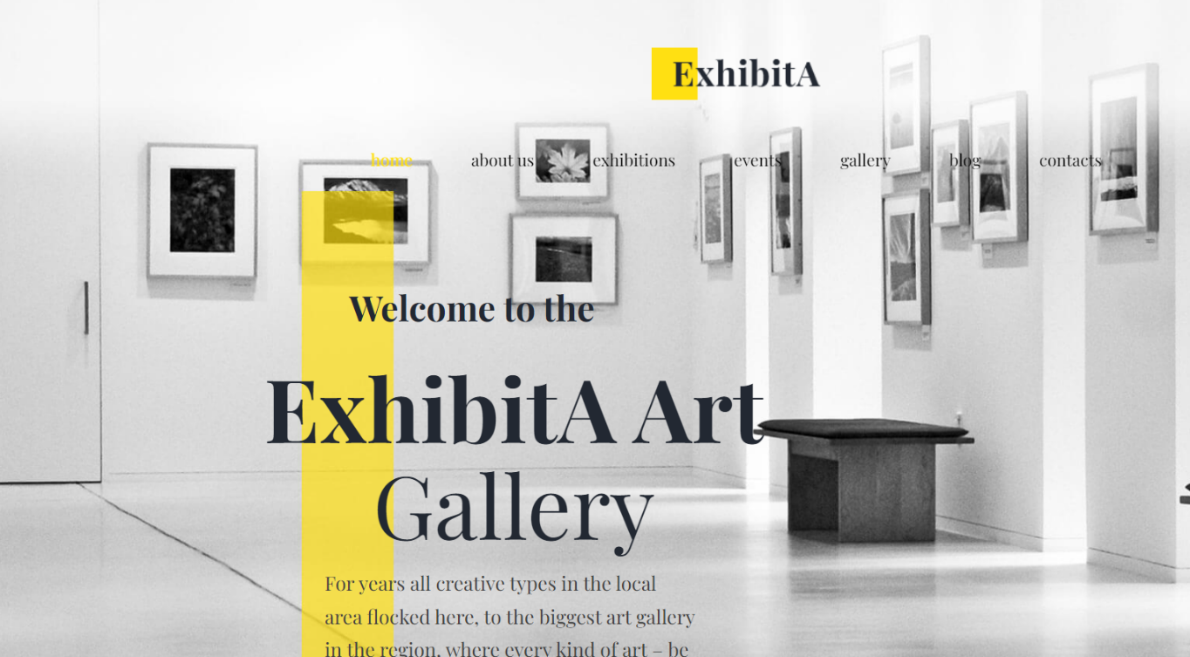

3.2.2 Artists

This section contains the list of the artists. Artists will be displayed as shown below

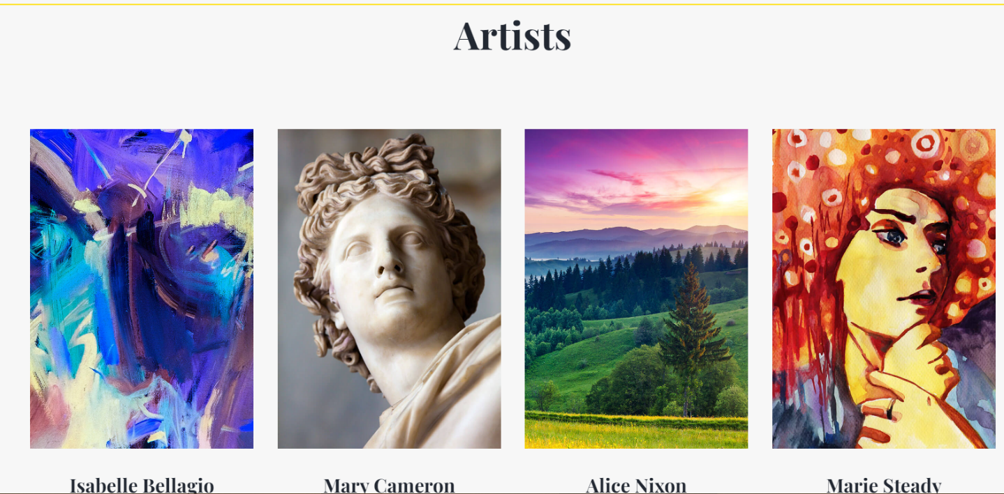

Each artist item contains:

* Photo
* Speaker name
* Art works

3.2.3 Local Gallery

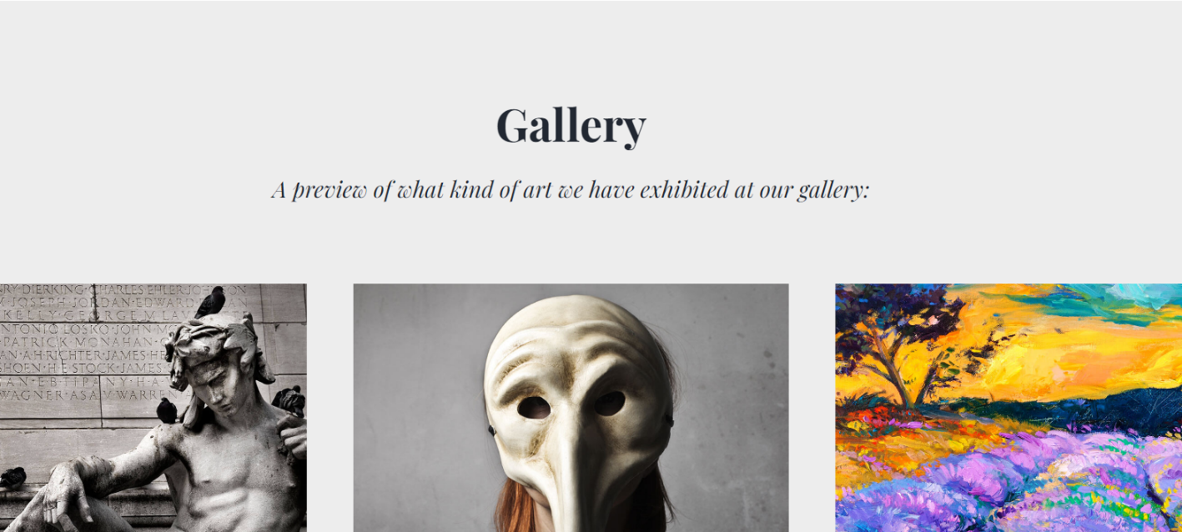

In summary, galleries are essential for nurturing creativity, promoting cultural exchange, and enriching communities through art.

3.2.4 Collections

In this section people looking for a certain category of paintings can choose according to their preference and taste

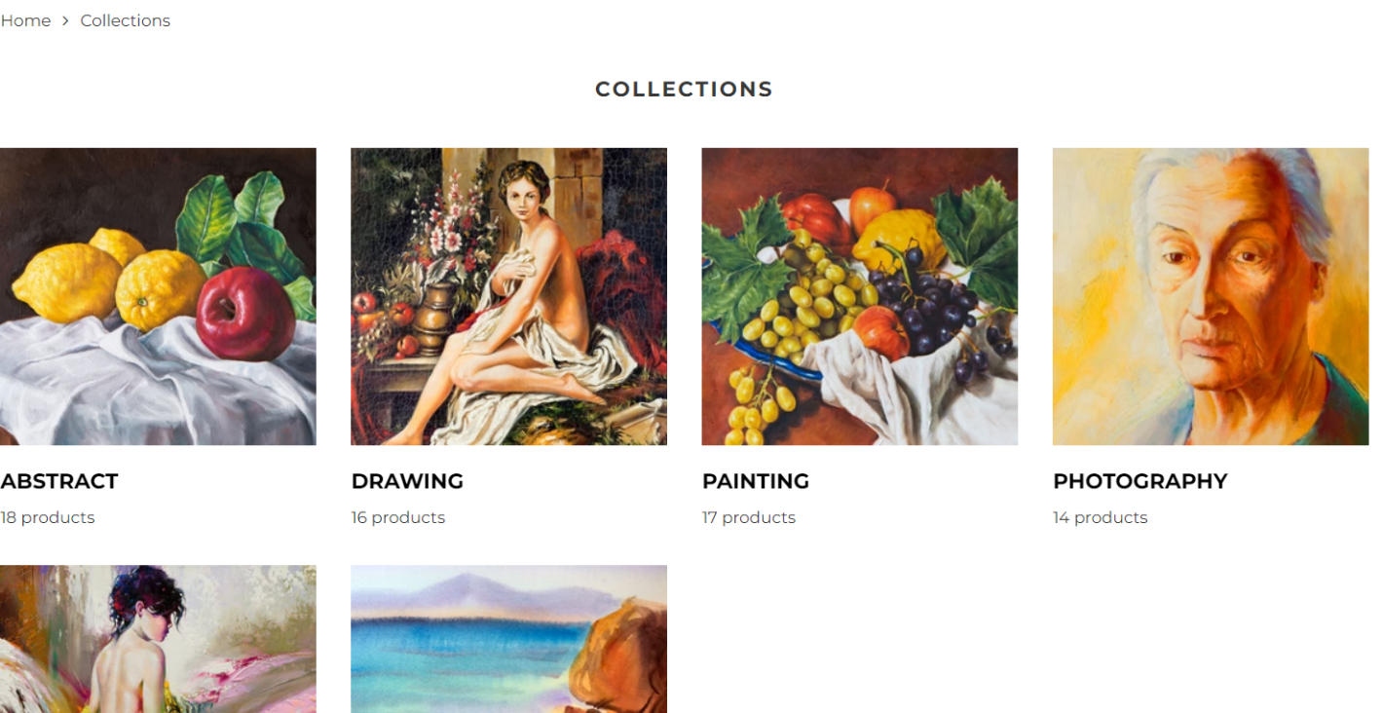

3.2.5 Contacts

This section provides contacts and all necessary information in the form of a blog and websites.

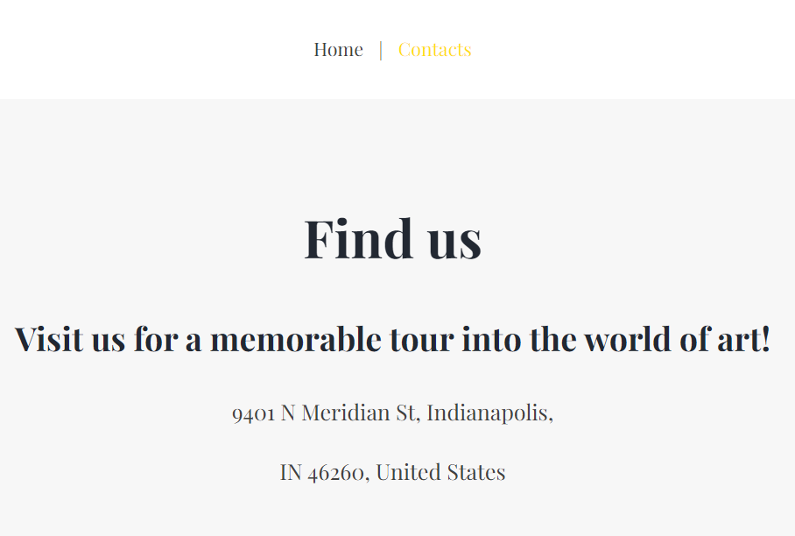

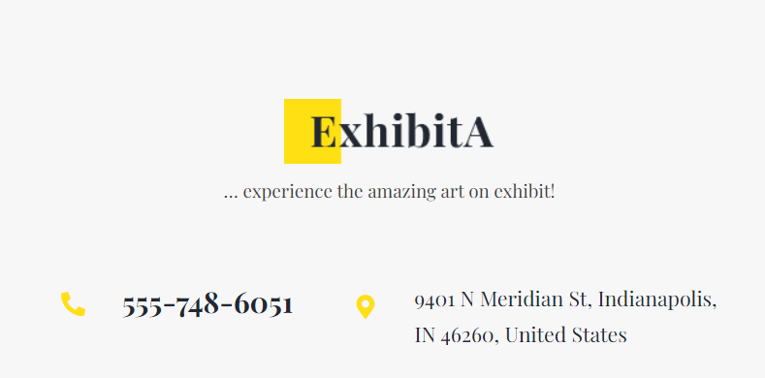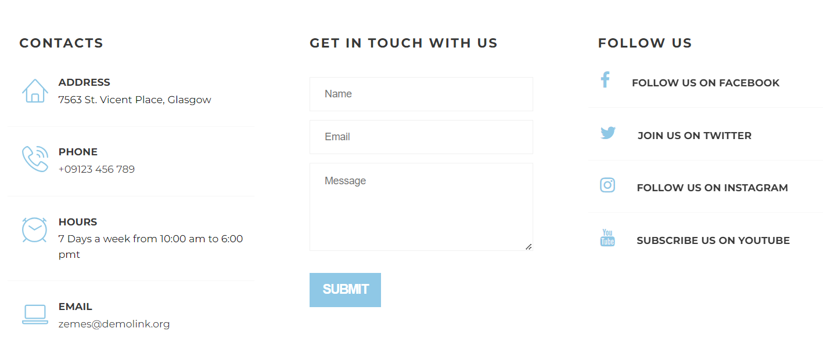

Each topic item contains:

* Subject
* Artists name
* Start time - end time
* Speaker photo

## 3.3Speakers

## 3.4Schedule

## 3.5Artists

## 3.6Blog

## 3.7Contact

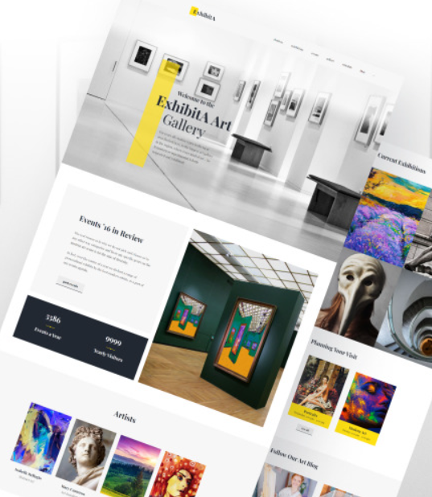

choosing art is vital for personal growth, cultural understanding, and community development. It enriches our lives, fosters creativity, and helps us navigate the complexities of the human experience. Embracing art is not only an investment in culture but also a commitment to understanding ourselves and the world around us.

# **4.Project duration and timelines**

Project will start: 24.09.2023

Project deadline: 19.10.2023

**1.12.2024 - 05.01.2025 - Design**

Develop a modern, responsive, and mobile-friendly website.

Improve user experience and navigation.

**08.01.2025 - 19.01.2025 - Main page. Content management**

Information will be added to the site. Information will be provided by the customer.